Third Party Remote Access
SSL VPN (AnyConnect)
User Guide

Security Notice

USE OF THIS DOCUMENT

This document is published for use by ExxonMobil business partners connecting to the ExxonMobil network and should only be viewed by ExxonMobil business partners that have signed with ExxonMobil an agreement covering access to ExxonMobil resources.

USER RESPONSIBILITY

Users of remote access services provided by ExxonMobil are responsible for complying with the security practices outlined in this document. Failure to comply may result in denial of access.

Copyright © 2018 by ExxonMobil Information Technology
All rights reserved

Reproduction by ExxonMobil-affiliated companies is permitted.

Table of Contents
SECTION 1 – GETTING STARTED - 4 -
1.1 VPN SERVICE - 4 -
1.1.1 Definition - 4 -
1.1.2 Cisco SSL VPN Client System Requirements - 4 -
1.1.3 Client Software License Agreement of Cisco Systems - 5 -
SECTION 2 – CONNECTING TO SYNCRUDE - 7 -
2.1Prep Work: Install the Cisco AnyConnect VPN Client on your computer - 7 -
2.2.1 Web Installation (32bit Environments) - 7 -
2.4.3 How to disconnect from the Syndrude Network - 11 -
SECTION 3 – SECURITY AND SERVICE DESCRIPTION - 11 -
3.1 Security - 11 -
3.2 Service Description Error! Bookmark not defined.
SECTION 4 - HELP Error! Bookmark not defined.
4.1 Who to Call for Help Error! Bookmark not defined.

SECTION 1 – GETTING STARTED

1.1 VPN SERVICE

1.1.1 Definition
Virtual Private Network (VPN) is a mechanism that provides a more secure network connection between two locations.

1.1.2 Cisco SSL VPN Client System Requirements
Computers where the VPN software will be installed should meet the minimum system requirements shown below.

Microsoft Windows

The Internet browser should be Internet Explorer 7.0 or later, and should enable ActiveX or have Sun JRE 1.4+ installed.

Windows Versions

Windows 8, 8.1, and 8.1 Update 1 (32-bit or 64-bit)

Windows 7 (32-bit or 64-bit)

Windows 10 all later version

The Cisco AnyConnect software requires a clean install.

If you upgrade from Windows XP or Windows Vista to Windows 7 or later, any previous version of the Cisco AnyConnect software should be uninstalled, and then reinstalled once the computer is running Windows 7. Reinstalling the software is necessary because the upgrade does not preserve the Cisco AnyConnect Virtual Adapter.

AnyConnect is compatible with 3G data cards which interface with Windows 7 or later via a WWAN adapter.

NOTE: Web-based installation May Fail on a 64-bit Windows version
This issue applies to Internet Explorer versions 10 and 11, on Windows 7 and 8. AnyConnect installation via WebLaunch does not support 64-bit versions of Internet Explorer. Please use 32-bit version of Internet Explorer to install WebLaunch.

If you only have 64-bit version of Internet Explorer, you are encouraged to login to MFT server (https://mft.exxonmobil.com) to download the AnyConnect client and install manually. Please refer to Section 2.2.2 for more information.

Windows Requirements

- Pentium class processor or greater
- 100 MB hard disk space
- Microsoft Installer, version 3.1

NOTE: You may need local administrative privilege rights on your desktop or laptop for installation of the Cisco SSL VPN Client. Please contact your company’s IT support if you encounter any issue during the software download or installation.

The computer must have access to the Internet through an Internet Service Provider (ISP), a company network, or a cellular (3G/4G) service.

The firewall between your computer and the Internet needs to allow SSL VPN traffic to the Internet. If you have trouble connecting with these instructions, your firewall administrator needs to know that the VPN connection uses TCP 443 (SSL/HTTPS) and UDP 443 (DTLS), and require that the rules allow outbound connection (i.e. from your network to Syncrude VPN gateways).

The Syncrude VPN gateway is diamond.syncrude.com.

1.1.3 Client Software License Agreement of Cisco Systems

THE SOFTWARE TO WHICH YOU ARE REQUESTING ACCESS IS THE PROPERTY OF CISCO SYSTEMS. THE USE OF THIS SOFTWARE IS GOVERNED BY THE TERMS AND CONDITIONS OF THE AGREEMENT SET FORTH BELOW. YOU (ON BEHALF OF YOURSELF AND THE BUSINESS ENTITY YOU REPRESENT) MUST AGREE TO THE FOLLOWING TERMS AND CONDITIONS IN ORDER TO USE THE SOFTWARE. IF YOU DO NOT AGREE TO THE FOLLOWING TERMS AND CONDITIONS THEN YOU ARE NOT ENTITLED TO USE THE SOFTWARE.

Ownership of the Software

1. The software contained in the Cisco AnyConnect VPN Client, Cisco SSL VPN Client, Cisco VPN Client, Cisco Secure Desktop, Smart Tunnels, Port Forwarding and additional SSL VPN delivered applets ("the Software"), to which you are requesting access, is owned or licensed by Cisco Systems and is protected by the United States copyright laws, laws of other nations, and/or international treaties.

Grant of License

2. Cisco Systems hereby grants you ("you" as used herein means you and the business entity you represent) the right to install and use any of the Software listed above on an unlimited number of computers, provided that each of those computers must use the Software only to connect to Cisco Systems products, and subject to export restrictions in Paragraph 4 hereof. You may make one copy of the Software for each such computer for the purpose of installing the Software on that computer. The Software is licensed for use only with Cisco Systems products, and for no other use.

Restrictions on Use and Transfer

3. You may also make one copy of the Software solely for backup and archival purposes. To this end, you may transfer the Software to a single set of disks provided you keep the disks solely for backup or archival purposes. You may not use the backup or archival copy of the Software except in conjunction with Cisco Systems products.

4. You may copy and distribute the Software to your third party business partners and customers solely and exclusively for the purposes of accessing your Cisco VPN appliances and thereby gaining remote access to your secure network. Each such distribution of the Software to a third party must be accompanied by a copy of this Client Software License Agreement. You may not copy or transfer the Software for any purpose, other than as specified in this Agreement, without the express written consent of Cisco. Without intending to limit the foregoing, you shall not post or otherwise make publicly available the Software to any external web site, file server, or other location to which there is unrestricted access, excluding delivery from your Cisco VPN appliance.

5. Cisco Systems will not provide end-user support (including Technical Assistance or TAC support) to any third party that receives the Software in accordance with Section 4 hereof. You shall be responsible for providing all support to each such third party. For permitted transfers, you may not export the Software to any country for which the United States requires any export license or other governmental approval at the time of export without first obtaining the requisite license and/or approval. Furthermore, you may not export the Software in violation of any export control laws of the United States or any other country.

6. You may not modify, translate, decompile, disassemble, use for any competitive analysis, reverse engineer, distribute, or create derivative works from, the Software or any accompanying documentation or copy thereof, in whole or in part.

7. The subject license will terminate immediately if you do not comply with any and all of the terms and conditions set forth herein. Upon termination for any reason, you (the licensee) must immediately destroy the Software, any accompanying documentation, and all copies thereof in your possession. You must also use commercially reasonable efforts to notify the third parties to whom you have distributed the Software that their rights of access and use of the Software have also ceased. Cisco Systems is not liable to you for damages in any form solely by reason of termination of this license.

8. You may not remove or alter any copyright, trade secret, patent, trademark, trade name, logo, product designation or other proprietary and/or other legal notices contained in or on the Software and any accompanying documentation. These legal notices must be retained on any copies of the Software and accompanying documentation made pursuant to paragraphs 2 through 4 hereof.

9. You shall acquire no rights of any kind to any copyright, trade secret, patent, trademark, trade name, logo, or product designation contained in, or relating to, the Software or accompanying documentation and shall not make use thereof except as expressly authorized herein or otherwise authorized in writing by Cisco Systems.

Limitation of Liabilities

10. INSTALLATION AND USE OF THE SOFTWARE IS ALSO GOVERNED BY A SEPARATE LICENSE AGREEMENT BETWEEN CISCO SYSTEMS AND THE PURCHASER OF THE PRODUCT (THE "END USER LICENSE"). THAT SEPARATE END USER LICENSE CONTAINS A DESCRIPTION OF ALL WARRANTIES PROVIDED BY CISCO SYSTEMS FOR THE SOFTWARE. CISCO SYSTEMS PROVIDES NO WARRANTIES FOR THE SOFTWARE OTHER THAN THOSE SET FORTH IN THAT AGREEMENT, AND ASSUMES NO LIABILITIES WITH RESPECT TO USE OF THE SOFTWARE BY YOU OR ANY THIRD PARTY.

SECTION 2 – CONNECTING TO SYNCRUDE

2.1 Prep Work: Enroll a mobile device to get Software Tokens

If you are a software token user, the first time you will need to enroll your mobile device in order to be able to connect to our VPN Gateways.

Using below link for set up Secure Auth access.
file:///C:/Users/farsyed/AppData/Local/Microsoft/Windows/INetCache/Content.Outlook/KEPTDKT5/SecureAuth%20Software%20Token%20-%20Enrollment%20guide.pdf

2.2Prep Work: Install the Cisco AnyConnect VPN Client on your computer

2.2.1 Web Installation (32bit Environments)
Type the SSL Gateway address in the Address bar as shown below and hit ENTER on your keyboard:

https://diamond.syncrude.com

This will connect to the SSL VPN gateway.
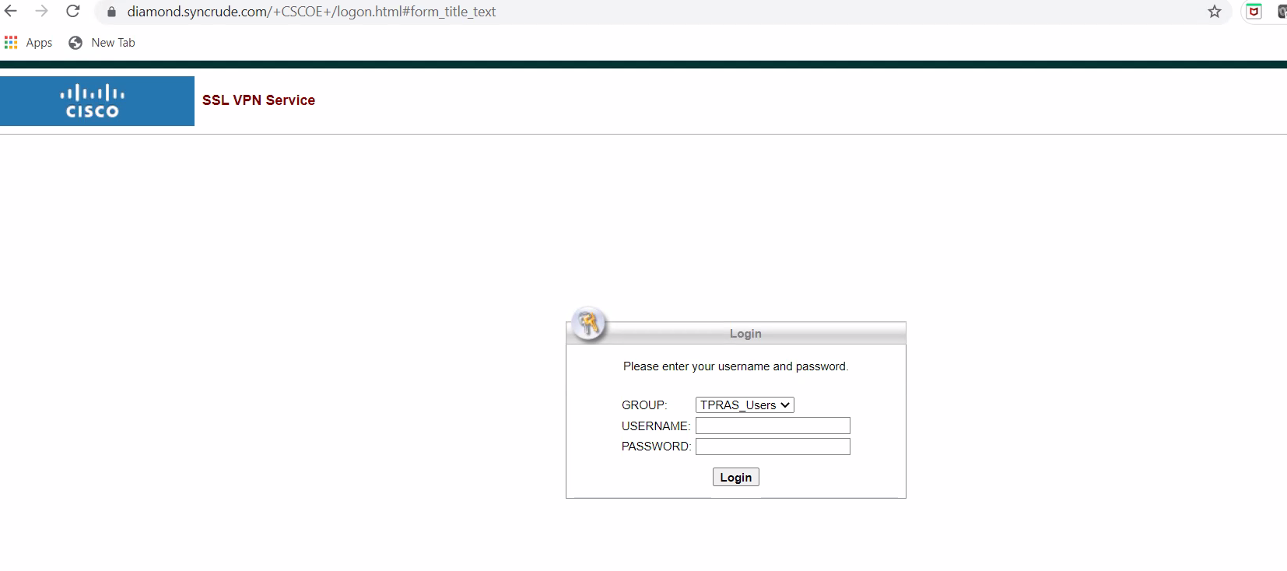

In the login window, enter the username and password from authorized Team.

you will be prompted to run the Cisco AnyConnect VPN Client add-on.

Right click on the yellow bar at bottom of your Internet Explorer session as shown, and select Install.
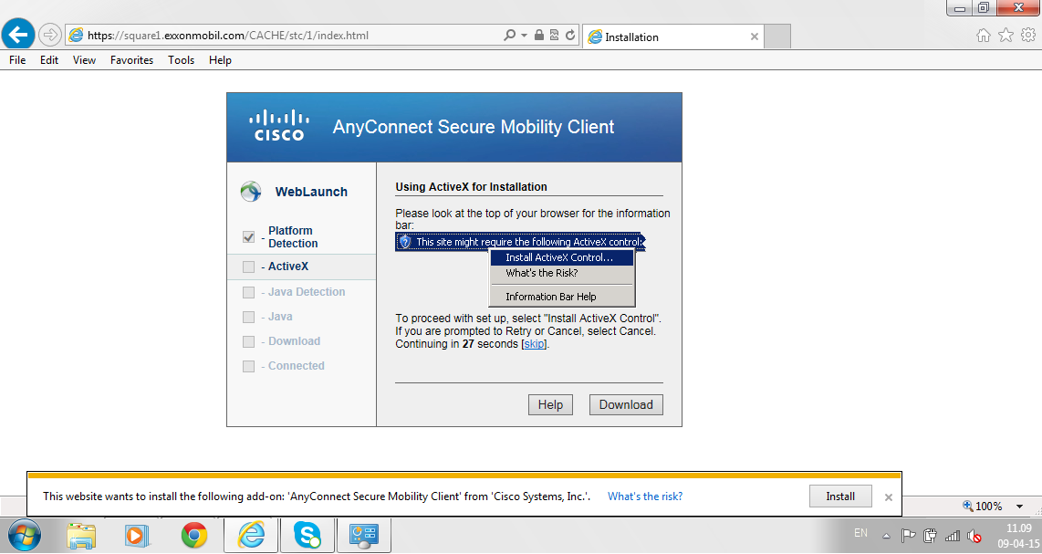

The VPN Client downloader will start the installation. Please wait and follow the instructions.
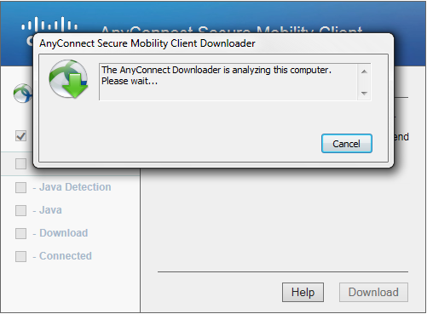
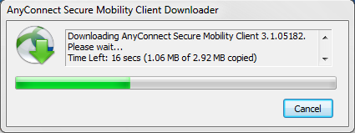

After installation completes, you will be connected to the Syncrude network via Cisco AnyConnect VPN Client.
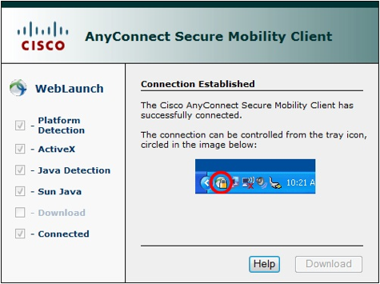

If the Web-based installation fails, please click Windows Desktop to download the installer package, save to your hard drive into a temporary directory (usually c:\windows\temp) or your desktop (c:\windows\desktop) and install the VPN client manually.
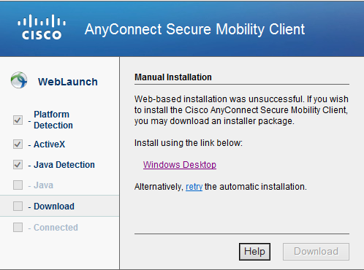

The Cisco AnyConnect VPN client icon can be found on the bottom right of your Windows Taskbar.

Right click on it; select Open AnyConnect and click to view the status of your connection.

NOTE: Please take note that your VPN connection will be automatically disconnect when not in use (idle) for a period of 30 minutes.

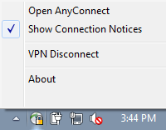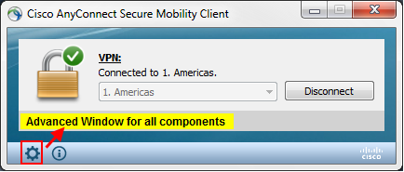

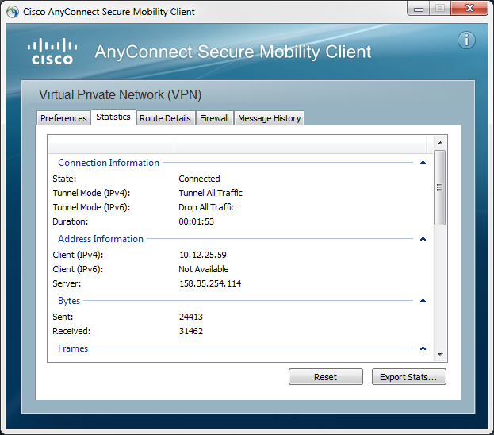

If Cisco AnyConnect VPN client did not automatically connect after installation and the field under Connect to: is blank, you may enter the following depending on the connection region (gateways) that business contact has informed you.

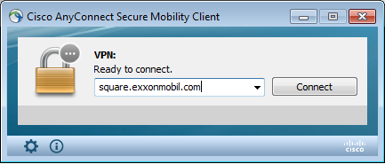

2.4.3 How to disconnect from the Syndrude Network

Right click on the Cisco AnyConnect VPN Client icon found on the bottom right of your Windows Taskbar and select VPN Disconnect to logout.

SECTION 3 – SECURITY AND SERVICE DESCRIPTION

3.1 Security
IMPORTANCE OF NETWORK SECURITY
Each Syncrude business partner is responsible for the proper handling and security of Syncrude information and systems. A number of precautions are appropriate when accessing to the Syncrudel network. Some of these are discussed in the following sections.

COMPUTER RISKS AND PRECAUTIONS
➔ Use a screen saver with password protection enabled on computers loaded with remote access software. The screen saver inactivity timeout should be set to 15 minutes or less.

➔ Keep your SecurID hardware token in a secure place, or carry it with you at all times.

➔ If possible, do not share computers among different users which have been configured for remote access to the Syncrude network and loaded with the remote access software.

➔ Log off when finished. (See section 2.3.3 of this guide)

SECURID/PIN RISKS AND PRECAUTIONS
➔ Do not write down your hardware token PIN or store it with your token.

➔ Do not share your hardware or software token with anyone else.

➔ Report a lost or stolen token to your Syncrude contact immediately so the access using that token can be disabled. (See paragraph below for details.)

➔ Select a strong, hard-to-guess PIN for activating your hardware token.

➔ Do not use an existing password used to access your LAN account or anything that resembles that password as your hardware token PIN.

